

Project Synopsis on “IntelleX”

Name: - Navroop (3819), Shail Sharma (3837)

# Problem Statement

# Deaf and mute individuals face significant communication barriers in their daily lives, hindering their ability to express themselves effectively and interact with others. Traditional methods of communication, such as sign language interpreters or written communication, are not always readily available or practical in various situations, leading to feelings of isolation and exclusion.

# Moreover, the lack of accessible communication tools limits deaf and mute individuals' access to essential services, education, employment opportunities, and social interactions. This results in a disparity in opportunities and hampers their full integration into society. Addressing these challenges requires innovative solutions that leverage cutting-edge technologies to bridge the communication gap between the hearing and speech impaired and the rest of the world. By developing an effective and efficient system for recognizing and translating sign language gestures into text and speech, we can empower deaf and mute individuals to communicate more freely and participate fully in all aspects of life.

# Introduction

# In a world where effective communication is fundamental, the barriers faced by deaf and mute individuals can be profoundly isolating. The inability to easily convey thoughts, feelings, and ideas through conventional means can hinder their integration into society and access to vital services. Recognizing this pressing challenge, our project endeavors to bridge the gap between the hearing and speech impaired and the rest of the world.We acknowledge the inherent difficulties faced by deaf and mute individuals in expressing themselves and understanding others, particularly in environments where sign language interpreters may not be readily available. To address this, we propose a groundbreaking solution harnessing the power of computer vision and machine learning.By leveraging advanced technologies, our solution aims to accurately recognize and translate sign language gestures into both text and speech in real-time. This innovation holds the promise of revolutionizing communication for the deaf and mute community, empowering them to engage more fully in everyday interactions, education, and professional settings.

# Technology Used

* + **Software Requirements**: The project is developed using Python along with essential libraries such as OpenCV (for image processing), Mediapipe (for hand/face tracking), Numpy (for numerical operations), Pickle (for data serialization), Matplotlib (for plotting), and Scikit-Learn (for machine learning tasks). A Python IDE is used for coding and testing.
  + **Hardware Requirement**: A camera is necessary to capture visual input, enabling real-time interaction for applications like gesture recognition or computer vision-based tasks.

# Flowchart

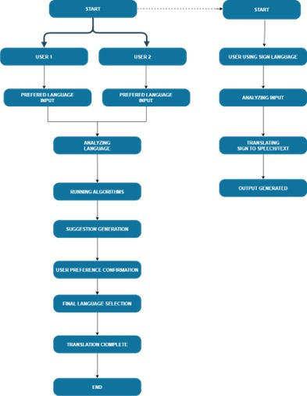

# References

1. YouTube: - <https://www.youtube.com/>
2. Wecapable: - <https://wecapable.com/tools/text-to-sign-language-converter/>
3. IEEE: - <https://ieeexplore.ieee.org/document/7353332>
4. ChatGPT: - https://chat.openai.com/
5. Gemini: - https://gemini.google.com/
6. GitHub: - https://github.com/
7. Kaggle: - https://www.kaggle.com/